
Meeting Date: 24th November 2025
Review Period:
FROM: 25 November 2024 TO: 24 November 2025
Input By: (Names of those present and/or providing information for the review)
- Tim Rocker – Sustainability Manager
- Bob Friend – Manager
- Sam Hignett - Director
- Samantha Wright – AvISO Consultant

The series of BS/ISO management standards require that: - “Top management shall review the organisation’s management system, at planned intervals, to ensure its continuing suitability, adequacy, and effectiveness. Reviews shall assess opportunities for improvement and the need for changes to the management system, including the policy, objectives, and targets. Records of the management reviews shall be retained”.
This management review agenda is designed to address the requirements of ISO 9001, 14001, 27001 and 45001. For the purpose of this review, only ISO 14001 issues are being considered.
Follow up actions from previous reviews will be considered and commented upon within individual sections.
More detail is given, as to what is reviewed under each agenda item, within the sections themselves.
Inputs (information) and Outputs (actions) are discussed under each individual heading as appropriate.

Contents
Status of Actions from Previous Management Reviews 4
Changes in External and Internal Issues that are relevant to the Management System 4
The Effectiveness of Actions Taken to Address Risks and Opportunities 4
Communication / Feedback from Stakeholders 5
Information on the Performance and Effectiveness of the Management System 5
Continual Improvement 6
The Adequacy of Resources and Resource Needs (Including Outputs) 6
Policy and Scope of Certification 6
Any Other Business 6

Status of Actions from Previous Management Reviews
Notes: Any outstanding action, actions that need re-appointing. If not complete, consider risks, opportunities, and resources at appropriate stages in this report.
Reference Documents:
- Previous Management Review Minutes
The management review has been formally documented for the first time. This process marks a significant step in establishing a structured approach to evaluating the performance and effectiveness of the management system. Through the documentation of this review, all relevant feedback from stakeholders has been captured, alongside information on the adequacy of resources and resource needs.

The review also includes a comprehensive assessment of continual improvement initiatives, the current policy and scope of certification, and any other pertinent business matters. Actions from previous management reviews have been tracked, with notes on any outstanding actions or those requiring re-appointment. Consideration has been given to associated risks, opportunities, and the allocation of resources at each appropriate stage of the review process.
Changes in External and Internal Issues that are relevant to the Management System
Notes: Have there been any significant changes to the management system and/or operational processes? Do these need to be agreed before being launched? Have there been any changes to legislation, or are any expected, that require changes to management system including working processes and/or documented procedures?
Reference Documents:
- QMS Documentation to be reviewed.
- Business Plans
- Legal Register
Changes to the Management System and/or Standards
Jota currently holds a Level 2 accreditation from the FIA. In line with their commitment to continual improvement, the organisation is actively working to enhance its management system with the objective of attaining Level 3 accreditation. This process involves a thorough assessment of existing procedures and the implementation of targeted improvements to meet the more stringent requirements associated with the higher accreditation level.
As part of these efforts, Jota has conducted a comprehensive review of its policies, ensuring that they reflect current organisational goals and compliance obligations. In addition, the Environmental Management System (EMS) manual has been updated to include these revised policies and document any changes to procedures, thereby supporting the pursuit of Level 3 FIA accreditation.

Changes in Operational Activity that may affect the Management System
Jota has recently completed a merger with the Cadillac Hertz team, which is based in the United States. This strategic partnership has provided new opportunities for collaboration and growth, particularly in the area of sustainability. Following the merger, the organisation has received awards recognising its achievements in sustainability.
Since joining forces with the Cadillac Hertz team, Jota has participated in several environmental meetings throughout the racing seasons. The minutes from these meetings have been diligently recorded, ensuring that all discussions and decisions regarding environmental practices are documented. These records serve as evidence of Jota’s ongoing commitment to sustainability and environmental stewardship within the merged team structure.

Compliance obligations, including statutory and regulatory requirements, changes, developments and evidence.
Jota maintains a comprehensive legal register that identifies 54 pieces of legislation and industry standards relevant to the organisation's environmental and sustainability commitments. This register serves as the cornerstone for ensuring ongoing legal and regulatory compliance within the business operations.
To further support compliance, Jota has subscribed to ISOvA’s legal register service. This subscription ensures that the organisation receives monthly newsletters, which inform them of any updates or changes to legislation and applicable standards. Upon receipt of these newsletters, Jota reviews the information and incorporates any pertinent changes into their own legal register, thereby maintaining its accuracy and relevance.

Jota have engaged AvISO Consultancy to undertake an environmental legal compliance audit on their behalf. The purpose of this audit is to independently verify Jota's adherence to relevant environmental legislation and standards. In addition, the audit will help to identify any opportunities for continual improvement within the organisation’s management system. The last audit took place on 12th November 2024, which identified 3 OFI’s.

Changes in needs and expectations of the interested parties.
During the recent management review, the interested parties register was thoroughly examined to ensure its ongoing relevance and effectiveness. The review process involved assessing the status of each listed party and gathering feedback on their significance to Jota’s environmental and sustainability objectives.
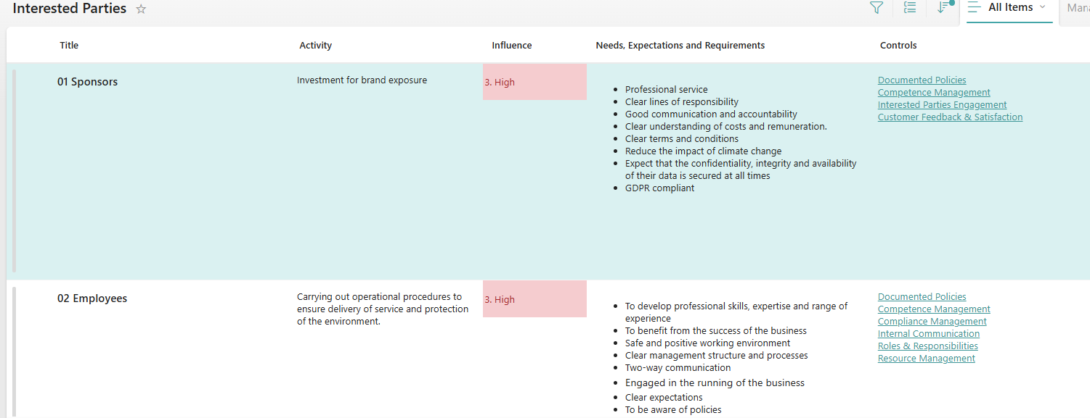

As part of the recent review of the interested parties register, several new stakeholders have been identified and added to ensure that Jota's environmental and sustainability objectives remain aligned with evolving external influences and expectations. The following groups have been formally recognised as interested parties:
- 13 SIG: This stakeholder group has been added to ensure their perspectives and requirements are considered in relevant aspects of the management system.
- 14 Local communities: Recognising the impact of Jota’s operations on surrounding communities, local residents and organisations have been included to reflect their importance in environmental and social initiatives.
- 15 Media and motorsports press: The inclusion of media outlets and motorsports journalists acknowledges their role in shaping public perception and reporting on the organisation’s sustainability performance.
- 16 Motorsports fans: Motorsports enthusiasts, as key supporters and stakeholders, have been added to ensure their expectations and feedback are considered in Jota’s sustainability and environmental strategies.
- 17 Academic and research institutions: By adding universities and research organisations, Jota recognises the value of knowledge exchange and collaboration in advancing environmental objectives.
- 18 Local businesses: Local commercial entities have also been included to foster strong community relations and to account for their interests in collaborative sustainability efforts.
This update to the register enhances Jota’s ability to respond to the changing needs and expectations of its stakeholders, supporting continuous improvement within the management system.

No other changes noted at this time.
The Effectiveness of Actions Taken to Address Risks and Opportunities
Notes: Review these sections of the management system and agree on any updates required.
Reference Documents:
- Risk and Opportunities Register
- Supplier Register
- Health and Safety Risks
Changes to the Context of the Organisation
The Environmental Management System (EMS) manual includes a detailed outline of Jota’s organisational context. In August 2025, this section was updated to reflect recent developments within the company. The update incorporated a change to the organisation’s name as well as revisions to the organisational chart, ensuring that the manual accurately represents the current structure and identity of the business.
As part of this update, a thorough review of the organisational context was conducted. This review specifically considered the recent merger between Jota and Cadillac Hertz, ensuring that the EMS manual aligns with the merged entity’s strategic direction, structure, and operational environment.

Potential Risks and Opportunities

In the course of reviewing organisational context and recent developments, several potential opportunities were identified. These opportunities are directly linked to the recent merger between Jota and Cadillac Hertz, as well as the subsequent updates to the Environmental Management System (EMS) manual and organisational structure.
To ensure that these opportunities are fully realised, the following actions have been undertaken:
- All identified opportunities have been documented and linked to specific updates in the EMS manual, particularly where changes in organisational structure and identity present avenues for improvement.
- Opportunities arising from the merger, such as enhanced operational efficiency, access to new resources, and the potential for integrating best practices, have been recorded for further development and monitoring.
By systematically documenting and reviewing these opportunities, Jota aims to strengthen its management system and support continuous improvement across all areas of operation.

Action: Ensure each opportunity is tracked within the Risk and Opportunities Register, ensuring ongoing assessment and alignment with the strategic direction of the merged entity.

Performance of External Providers (Suppliers)
Jota maintains a documented and approved supplier performance review process within its EMS toolbox, as detailed in supplier list 25. This list highlights the top 16 key suppliers whose performance is subject to ongoing evaluation.
During the Management Review (MR), discussions were held regarding supplier performance, with particular emphasis on issues concerning delivery times. The identification of delivery time challenges was recognised as a key area for monitoring and improvement within the supplier review process.
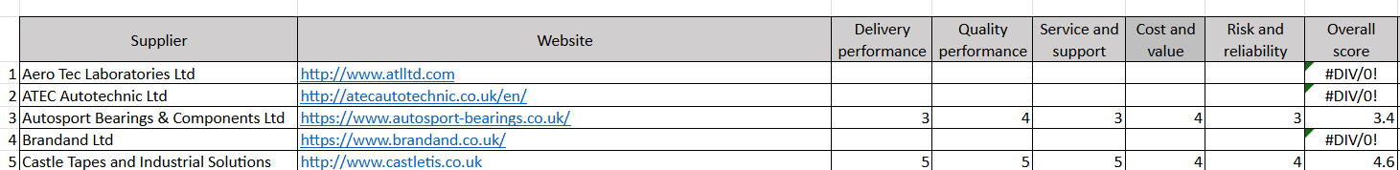

Action: Assess and document any environmental impacts caused by late deliveries, such as increased emissions from expedited transport. Record these risks and corrective actions in the risk register and ensure improvement plans are monitored and reported during future Management Reviews to demonstrate compliance with FIA Level 3 requirements.
Review of Environmental Aspects including Significant Aspects
Jota maintains a comprehensive aspect and impacts register, which underwent a thorough review and update on 05/08/2025. This update included a detailed evaluation of the organisation’s significant environmental aspects.
Through this process, Jota identified six significant aspects relating to its operations:
- Use of company vehicles
- Transport of vehicles
- Transport of people and equipment to and from race meetings
- Generation of factory and office waste
- Use of an oil-fired (kerosene) boiler for heating
- Use of an oil-powered boiler for heating
For each significant aspect, specific aims, risk treatments, objectives, and key performance indicators (KPIs) have been established. These measures enable the organisation to monitor and continually improve its management of these significant environmental aspects.

Action: To ensure that all relevant stakeholders are fully informed and engaged, Jota will share details of the significant aspects and associated objectives with stakeholders. In addition, a PowerPoint presentation will be distributed to raise awareness and provide further clarity on these key topics.

Communication / Feedback from Stakeholders
Notes: Documented decisions on communication. The review process for assessing feedback as well as the results. Could improvements be made in either instance?
Reference Documents:
- Evidence of communication
- Feedback, satisfaction, etc
- Training records
Decision on what, to whom, how, and who will Communicate with Stakeholders
Jota maintain a documented communications plan, accessible within their toolbox, which clearly outlines the approach to stakeholder communication. The plan specifies the information that will be communicated, identifies the recipients, establishes the timing and frequency of communications, and details the methods to be used. Furthermore, it describes the types of records maintained to support each communication activity and articulates the overall purpose of the communications process.

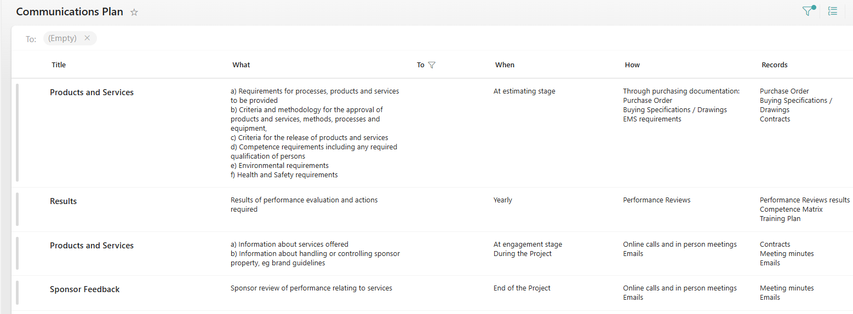

Action: It is important to note that there are still items within the communications plan that require completion. These outstanding actions should be addressed promptly to ensure that the plan remains comprehensive and effective. The plan does not include the communication requirements of significant aspects.
Customer Satisfaction and Feedback from Relevant Interested Parties
Positive feedback from Cadillac regarding water stations etc.

All 18 staff members confirmed receipt and understanding of Environmental Policy v2.0 and the Environmental Awareness Communication by 31 March 2026, as recorded in the Environmental Awareness Email Log (retained as audit evidence). The communication was issued by the Sustainability Manager (Timothy Rocker) on 26 March 2026 and covered the significant environmental aspects of the team’s operations, current EMS objectives and performance data, day-to-day environmental responsibilities, and the signed Environmental Policy v2.0. No concerns or negative feedback were raised. Jacob Garland confirmed receipt on 26 March 2026; all remaining 17 staff members confirmed by 31 March 2026. The feedback mechanism (contact Tim Rocker or Leon Price with environmental concerns or improvement suggestions) was communicated to all staff as part of this process and is formally documented in the Environmental Scope Assessment (ENV-SCOPE-001, March 2026).

Information on the Performance and Effectiveness of the Management System
Notes: What is monitored, how is it recorded, and is this process up to date? What is being done with the data collected to improve understanding related to risk, opportunity, and resources?
Reference Documents:
- Data
- Objectives Register
- Performance Report
Trends in the extent to which objectives have been met and actions required for any not met
During the Management Review, the objectives outlined in the EMS toolbox were carefully examined. In this review, agreement was reached on five new objectives that had previously been pending. Jota currently maintains a total of eleven documented objectives, each with its own target completion date. As part of the meeting, all these objectives were systematically reviewed, and their progress was updated accordingly.
Trends in Process Performance and Conformity of Products and Services
The following performance data has been compiled for the review period and the post-review period to March 2026. All KPI data is documented in the KPI Baseline Methodology 2024 and VSME Carbon Footprint Report 2024, both retained as formal audit evidence.
Carbon Footprint (GHG Performance — 2024 Baseline): The 2024 VSME carbon footprint baseline has been established using the AvISO VSME toolbox in accordance with the GHG Protocol and DEFRA 2024 emission factors. The total market-based carbon footprint for the 2024 WEC season is 2,005.72 tCO₂e, comprising: Scope 1 (direct emissions) 28.09 tCO₂e; Scope 2 (purchased energy, market-based) 0.00 tCO₂e; Scope 3 (value chain) 1,977.63 tCO₂e. Scope 2 is confirmed at zero under a market-based approach owing to the ScottishPower 100% renewable electricity tariff.
Race Fuel — Total Excellium Racing 100 (Certified Bioethanol): A significant finding during the post-review period was the formal identification of the team’s race fuel as Total Excellium Racing 100, a certified 100% sustainable bioethanol compliant with EU Renewable Energy Directive II (RED II), achieving a lifecycle GHG reduction of ≥65% versus fossil fuel. Under DEFRA 2024 reporting guidance, biogenic CO₂ from bioethanol combustion is excluded from Scope 1 reporting; only N₂O and CH₄ combustion emissions are counted. The 27,566 litres of race fuel consumed in the 2024 season therefore contributes only 0.24 tCO₂e to Scope 1 — compared to approximately 63.7 tCO₂e had an incorrect fossil fuel factor been applied. The well-to-tank (WTT) upstream emission of 4.38 tCO₂e has been correctly allocated to Scope 3 Category 3. The full rationale and corrected calculations are documented in the KPI Baseline Methodology 2024 (Calculation Workings sheet).
Energy Performance: Electricity consumption at the Bells Yew Green facility was confirmed at 50.39 MWh for the full year 2024. For 2025, confirmed metered consumption to 17 December 2025 is 46.16 MWh, with an extrapolated full-year estimate of 47.19 MWh — a year-on-year reduction of approximately 6.3% against the 2024 baseline. The EMS Objective 5 target is a 10% reduction by end of 2025. The current trajectory is positive and the trend is heading in the right direction; however, additional consumption reduction measures should be considered to close the remaining gap to the 10% target. Normalised figures: 6.30 MWh per event (2024) and 5.90 MWh per event (2025 estimate). Water consumption data for 2025 remains outstanding pending confirmation from the building landlord; the 2024 baseline of 320 m³ is carried forward in the interim.
Waste Management: Waste collection is managed via two contracted service providers. Slicker Recycling handles liquid waste (oils and fluids) and holds ISO 14001:2015 and ISO 9001 certification (valid to October 2026), FORS Bronze, and SafeContractor accreditation. Veolia manages non-hazardous industrial and mixed recyclables under Waste Transfer Notice CN590345, valid to 30 September 2026, signed by Leon Price on 18 March 2026. Waste performance data for January to February 2026 (the most granular data available from Veolia) records a total of 1,462 kg collected: Non-Hazardous Industrial (Front End Loader 8yd3/6.1m³) 420 kg in January and 540 kg in February; Recyclate — Mixed (Euro Bin 1100 Ltr) 253 kg in January and 249 kg in February. Diversion from landfill: 100% across all waste streams. Overall recycling rate: 34.34%, an improvement on the estimated 2024 baseline of 25%. Objective 4 (zero waste to landfill) is performing ahead of target and is on track.
Transport Baseline: A 2024 transport log baseline has been established, covering air freight, road freight, and business travel for the full 2024 WEC season. All air freight was operated via DHL chartered flights, covering 12 pallets across the season. Road freight haulage and business travel data are recorded in the Transport Log 2024. Active recording of 2025 freight data has commenced to build year-on-year comparison data for Objective 9 (7.5% transport emissions reduction target).
Pollution Incidents: Zero pollution incidents were recorded during the review period (25 November 2024 to 24 November 2025). No spillages, regulatory breaches, or enforcement actions were identified. This is consistent with the team’s operational controls and Objective 7 (zero pollution incidents).
Supply Chain Performance: As at March 2026, 16 key suppliers are tracked on the Approved Supplier List. Environmental credential surveys were issued to all 16 suppliers; 13 have responded. Three suppliers — Aero Tec Laboratories Ltd, Euro Car Parts, and RS Components Ltd — hold ISO 14001 certification (18.75% of the tracked supply chain). Nine suppliers (56.3%) have a documented environmental policy on file. Three suppliers (Castle Tapes, CES Europe, MRTC) have not yet responded to the survey; follow-up communications are ongoing. Full supplier performance data is retained in the Approved Supplier List 2025.
Results from Personal Development Training and Awareness
An Environmental Awareness Communication was issued to all staff by the Sustainability Manager (Timothy Rocker) in March 2026, satisfying the requirements of ISO 14001:2015 Clause 7.3 (Awareness). The communication covered: the significant environmental aspects of the team’s operations; current EMS objectives and performance data; day-to-day environmental responsibilities (waste segregation, spill and incident reporting, procedural compliance); and the signed Environmental Policy v2.0, attached directly to the email. Responses and acknowledgements are being recorded in the Environmental Awareness Email Log, retained as audit evidence. No formal external environmental training events were undertaken during the immediate review period; the awareness communication constitutes the primary staff engagement and competence activity for this period.

Continual Improvement
Notes: Are there, or have there been, any significant issues relating to the internal audit process or the output? Have there been any significant changes to the management system, process, or procedures in relation to corrective or preventative action employed? Has the process highlighted any opportunities for improvement, if so, what are the potential risks, opportunities, and resource requirements?
Reference Documents:
- Non-conformity Log
- Internal Audits
- Internal Audit Plan
Non-conformities and Corrective Actions
To date, Jota has not had any non-conformities identified during either internal or external audits. This reflects a strong adherence to established processes and compliance requirements. Furthermore, there have been no incidents reported that meet the criteria for formal notification or escalation.

However, it is noteworthy that one observation was raised during the external audit carried out by the FIA. This observation was formally documented on 04/06/2025. While not a non-conformity, the observation highlights an area for potential attention and improvement, as identified by the external auditor. This was reviewed and agreed closed out.
Opportunities for Improvement
Since November 2024, a total of 27 Opportunities for Improvement (OFIs) have been identified and formally raised. Of these, 22 originated from internal audit activities, demonstrating the effectiveness of ongoing internal review processes in highlighting potential areas for enhancement. The remaining 5 OFIs were identified during the external audit conducted by the FIA, underscoring the value of external evaluation in supporting continual improvement.
Currently, 2 OFIs are still open. These outstanding items were discussed and reviewed during the Management Review (MR) to ensure appropriate attention and resolution.
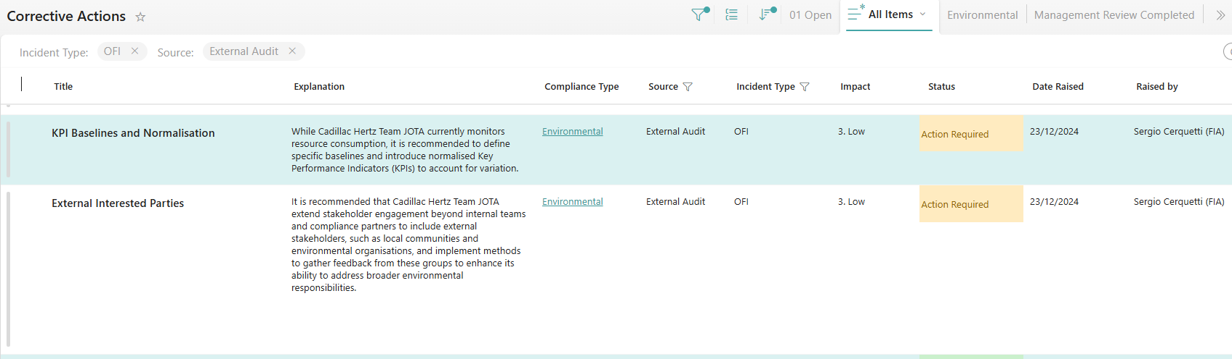

As agreed during the meeting, external interested parties can now be closed out. Any new interested parties have been identified and added to ensure that all relevant external stakeholders are captured appropriately.
The baseline for Key Performance Indicators (KPIs) and the normalisation methodology were discussed during the meeting. Post-review (December 2024), KPI normalisation has been formally completed. The KPI Baseline Methodology document was produced, establishing the 2024 VSME carbon footprint baseline. Note: the initial baseline figure was subsequently corrected in March 2026 following identification of the race fuel as certified bioethanol (Total Excellium Racing 100, EU RED II compliant). The corrected 2024 total is 2,005.72 tCO₂e (Scope 1: 28.09 tCO₂e + Scope 2: 0.00 tCO₂e + Scope 3: 1,977.63 tCO₂e). Scope 2 is confirmed as zero under a market-based approach due to the ScottishPower renewable electricity tariff. Full correction rationale is documented in the KPI Baseline Methodology 2024 (Calculation Workings sheet). This matter is now closed.

Continuing Suitability, Adequacy, and Effectiveness of the Management System
Based on the review conducted today, the management system continues to demonstrate ongoing suitability for Jota. The processes and controls in place remain aligned with organisational objectives and compliance requirements, ensuring that the system supports effective operations and continual improvement. No significant concerns have been identified that would impact the current suitability of the management system.

Any need for changes to the Management System
During the Management Review (MR) conducted today, no changes to the management system were identified. However, it was noted that additional clarification regarding Key Performance Indicators (KPIs) is required. This clarification aims to further enhance the effectiveness and understanding of KPIs within the organisation. The focus will remain on refining the definitions and methodologies associated with KPIs, ensuring they continue to support ongoing improvement and accurate performance measurement.

Evidence of Compliance
To verify compliance, Jota engaged AvISO Consultancy to conduct an independent environmental legal compliance audit. The most recent audit, completed on 12 November 2024, confirmed adherence to applicable legislation and standards, identifying three Opportunities for Improvement (OFIs). These OFIs have been documented and are being addressed through Jota’s continual improvement process.

In preparation for the upcoming 3 star audit, it is essential to undertake a comprehensive legal compliance review. This review will serve as documented evidence of the organisation’s continued adherence to all relevant environmental legislation and standards.
The results of the legal compliance review should be formally recorded and any identified non-conformities or opportunities for improvement addressed through the organisation’s corrective action process. This approach will strengthen the organisation’s position during the 3 star audit and support the ongoing commitment to maintaining high standards of compliance and continual improvement.

Action: Conduct an internal legal compliance audit.

The Adequacy of Resources and Resource Needs (Including Outputs)
Notes: Can any issues noted be linked to resources or lack of them? What are the resource requirements of any opportunities and highlighted?
Reference Documents:
- As required

During the management review, consideration was given to the adequacy of resources and any associated requirements in relation to the organisation’s ongoing activities and identified opportunities for improvement. Following a thorough discussion, it was confirmed that there are currently no additional resource requirements noted. The existing resources are deemed sufficient to support current operations and address identified opportunities within the continual improvement process.

Policy and Scope of Certification
Notes: Including a review of the company Policy Statements and Scope of the Management System – are these still reflective of the nature of the business or is there a need for a change?
Reference Documents:
- Copies of Policies and Scope
The scope of EMS has been defined as “The engineering, build, preparation and running of racing cars for competitive sport” During the review, it was confirmed that the scope accurately reflects the core activities undertaken at the headquarters. However, the EMS also manages significant environmental aspects and KPIs related to transport and operations at race venues worldwide. These activities are included within the management system but are not explicitly referenced in the documented scope.

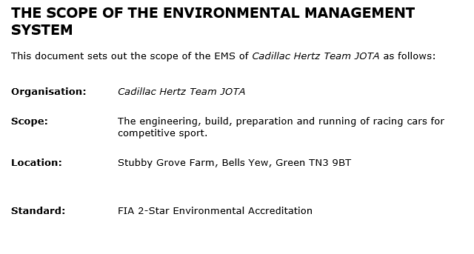

The below scope was discussed, and the management team are going to go away and consider updating to:
- “The engineering, build, preparation and running of racing cars for competitive sport, including associated activities at Stubby Grove Farm and all race venues where the team operates.”
The management team will reflect on this proposed scope update to ensure it accurately encompasses all core activities and associated operations relevant to the organisation’s current and future needs.

Action: Agree on scope for 3-star application and update associated documentation.

During the meeting, a comprehensive review of the company’s Environmental Policy was conducted. It was collectively agreed that the policy continues to meet all relevant requirements and that a further update would be undertaken in early 2026 to align the policy with the FIA 3-Star Environmental Accreditation requirements. A comment was added to the toolbox to document this discussion and provide evidence of the annual policy review. Post-Review Amendment (March 2026): The Environmental Policy was subsequently updated to Version 2.0 in March 2026, incorporating specific commitments to FIA 3-Star accreditation, annual VSME carbon reporting, sustainable fuel usage, a 4% annual carbon reduction target, and zero landfill waste. Environmental Policy v2.0 has been signed by Sam Hignett (Managing Director), March 2026, and is filed as audit evidence.
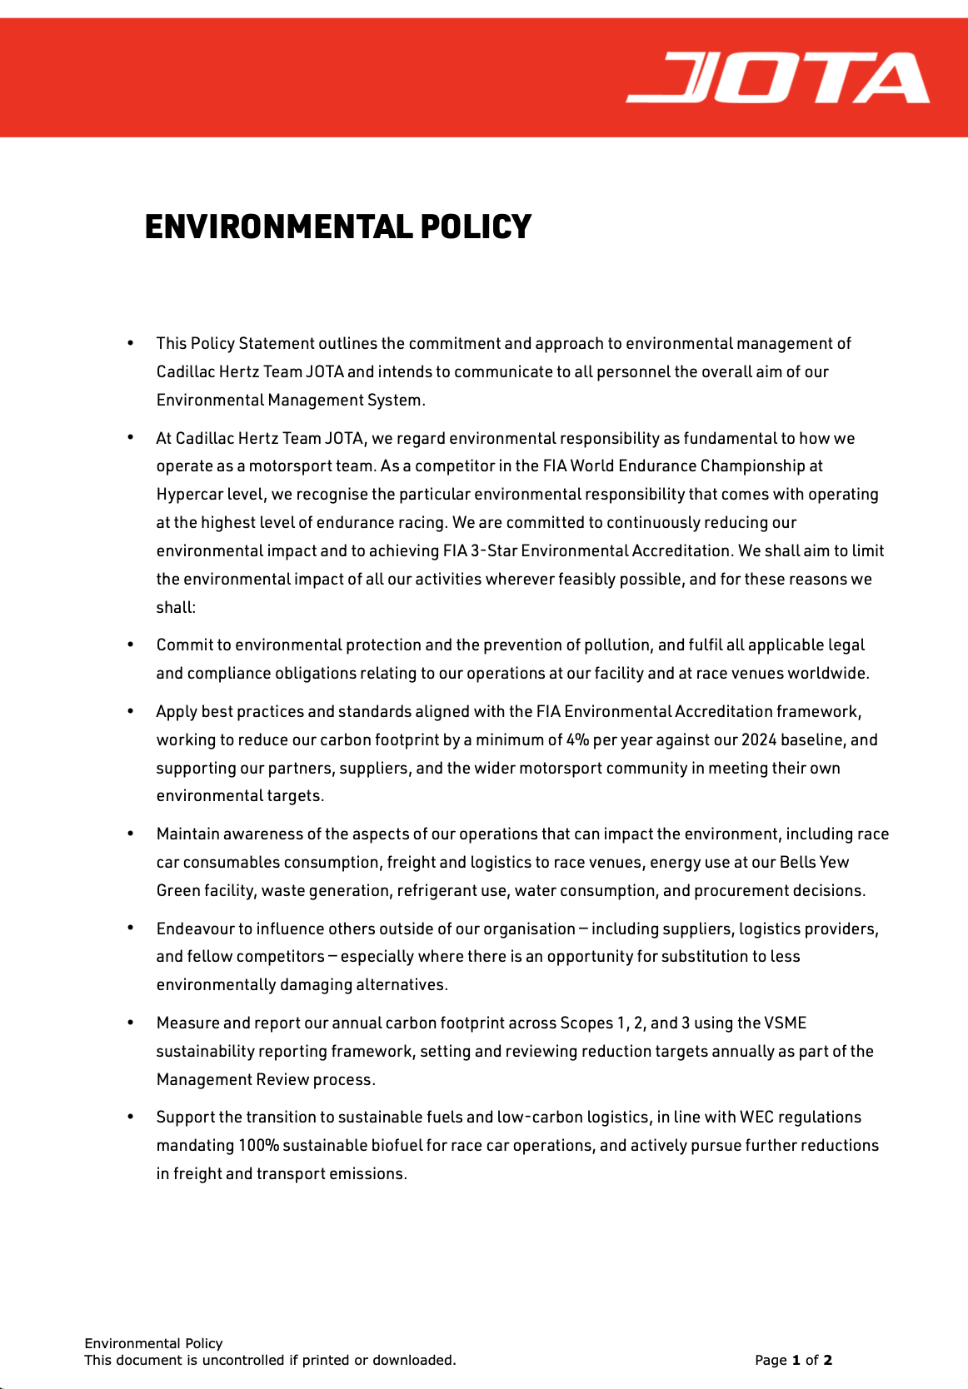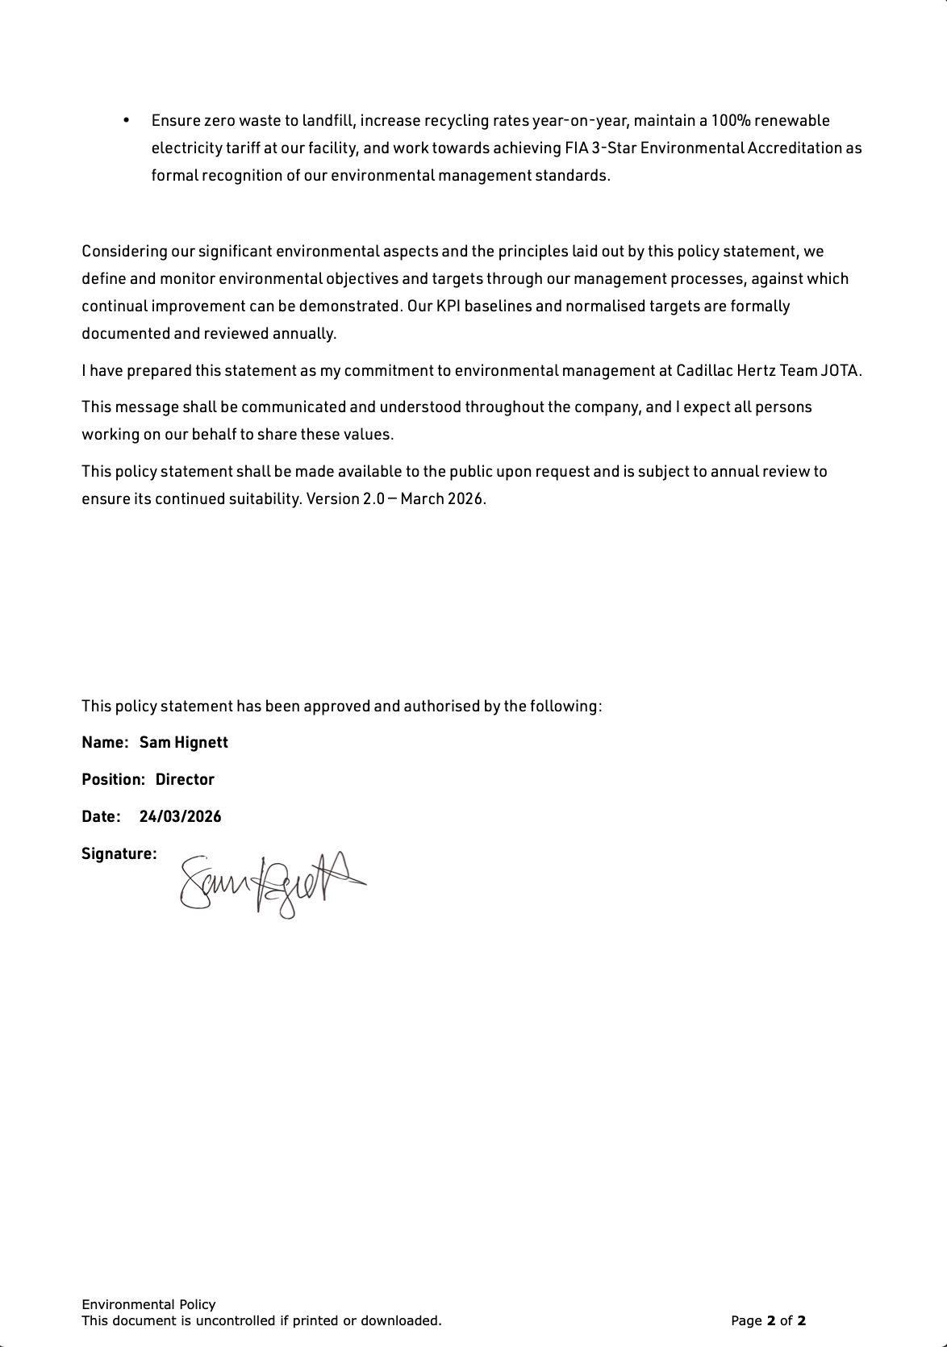

Any Other Business

No additional items were raised for discussion under Any Other Business during the meeting. At this time, there are no further matters to note or address.

End of meeting.
Post-Review Amendments (March 2026)
Note: This management review was conducted on 25 November 2024. In line with ISO 14001:2015 best practice, the following amendments have been made to this document following the review meeting to reflect actions completed and decisions made in the period up to March 2026. These updates demonstrate the ongoing operation and improvement of the EMS and are recorded here to ensure this document remains current and suitable for submission as audit evidence for the FIA 3-Star Environmental Accreditation.
Summary of Post-Review Actions Completed
- KPI Baseline Methodology finalised (December 2024, corrected March 2026): 2024 VSME carbon footprint baseline established at 2,005.72 tCO₂e (corrected from initial figure of 2,075.22 tCO₂e following identification of race fuel as certified bioethanol — see note below). Scope 1: 28.09 tCO₂e, Scope 2: 0.00 tCO₂e (market-based, renewable tariff), Scope 3: 1,977.63 tCO₂e. Carbon Footprint Correction (March 2026): The team’s race fuel, Total Excellium Racing 100, has been confirmed as a certified 100% sustainable bioethanol (EU RED II compliant). Under DEFRA 2024 guidance, biogenic CO₂ from bioethanol combustion is excluded from Scope 1; the race fuel Scope 1 contribution is 0.24 tCO₂e (not 63.7 tCO₂e as an incorrect fossil diesel factor would produce). WTT upstream emissions of 4.38 tCO₂e are correctly allocated to Scope 3 Cat 3. Full rationale documented in KPI Baseline Methodology 2024 (Calculation Workings sheet).
- Environmental Policy updated to Version 2.0 and signed (March 2026): Policy rewritten to specifically reference Cadillac Hertz Team JOTA, FIA 3-Star Environmental Accreditation target, annual VSME carbon reporting commitment, 4% annual carbon reduction target, sustainable fuel usage (WEC biofuel mandate), zero landfill target, and renewable electricity. Environmental Policy v2.0 has been signed by Sam Hignett (Managing Director), March 2026. Signed copy filed as audit evidence.
- Environmental Awareness Communication issued (March 2026): All staff emailed by the Sustainability Manager (Timothy Rocker) covering significant environmental aspects, EMS objectives and performance data, day-to-day environmental responsibilities, and the signed Environmental Policy v2.0 attached directly. Acknowledgements being recorded in the Environmental Awareness Email Log. This constitutes evidence of staff awareness under ISO 14001:2015 Clause 7.3.
- Supplier Register updated (March 2026): The approved supplier list now records 16 key suppliers (updated from 15 referenced at time of review). Environmental credential surveys issued to all 16; 13 have responded. 3 suppliers hold ISO 14001 (18.75%); 9 hold a documented environmental policy (56.3%). Three non-responders (Castle Tapes, CES Europe, MRTC) being chased.
Outstanding Actions (to be completed before audit): ✔ Environmental Policy v2.0 signed by Sam Hignett (Managing Director), March 2026 — COMPLETE. ✔ Process performance findings inserted (March 2026) — COMPLETE. ✔ Staff awareness feedback inserted (March 2026) — COMPLETE. All 18 staff confirmed receipt and understanding of Environmental Policy v2.0 by 31 March 2026. Review period confirmed: FROM: 25 November 2024 TO: 24 November 2025. Outstanding: Sam Hignett to sign and date the Management Review document prior to audit submission.
Approved by:
Name: Sam Hignett
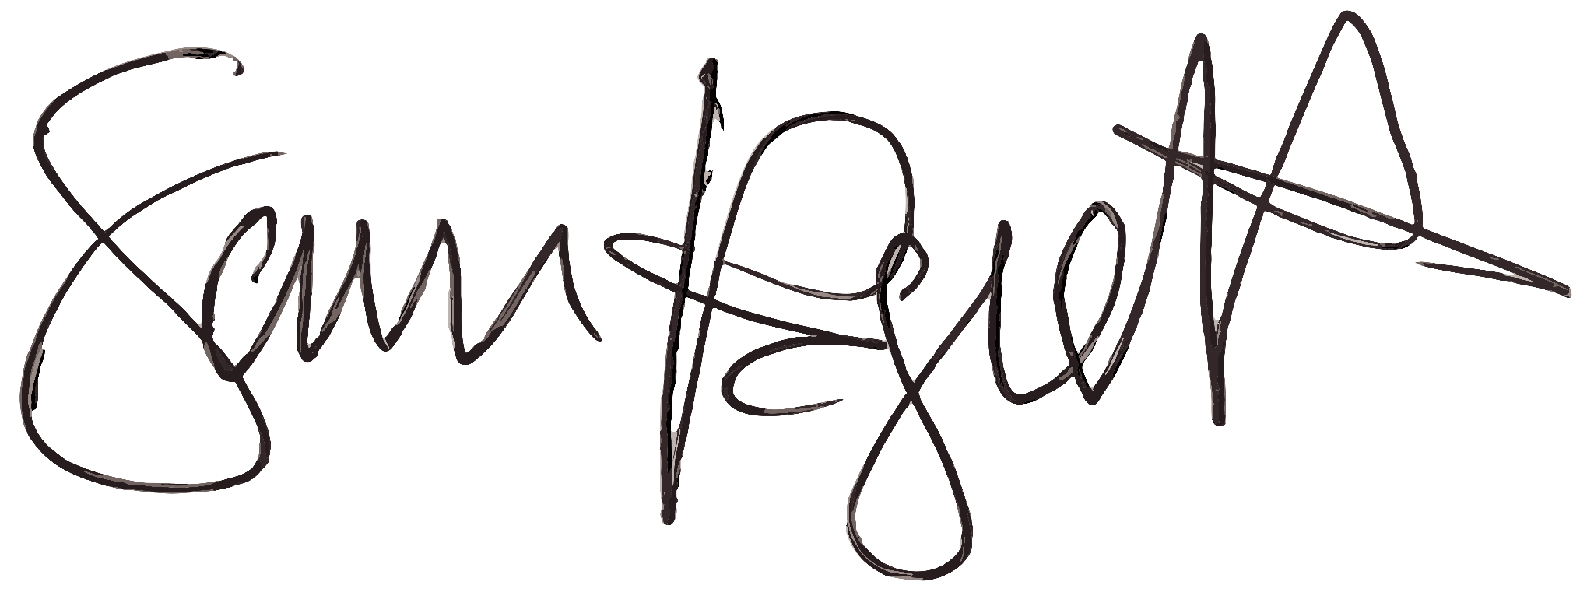
Position: Managing Director, Cadillac Hertz Team JOTA
Signature:

Date: 12.01.2026

